Outstanding Issues:

1. Expertise area on the “find a lawyer toolbar should be a drop down (similar to language) with a list limited to values as per below

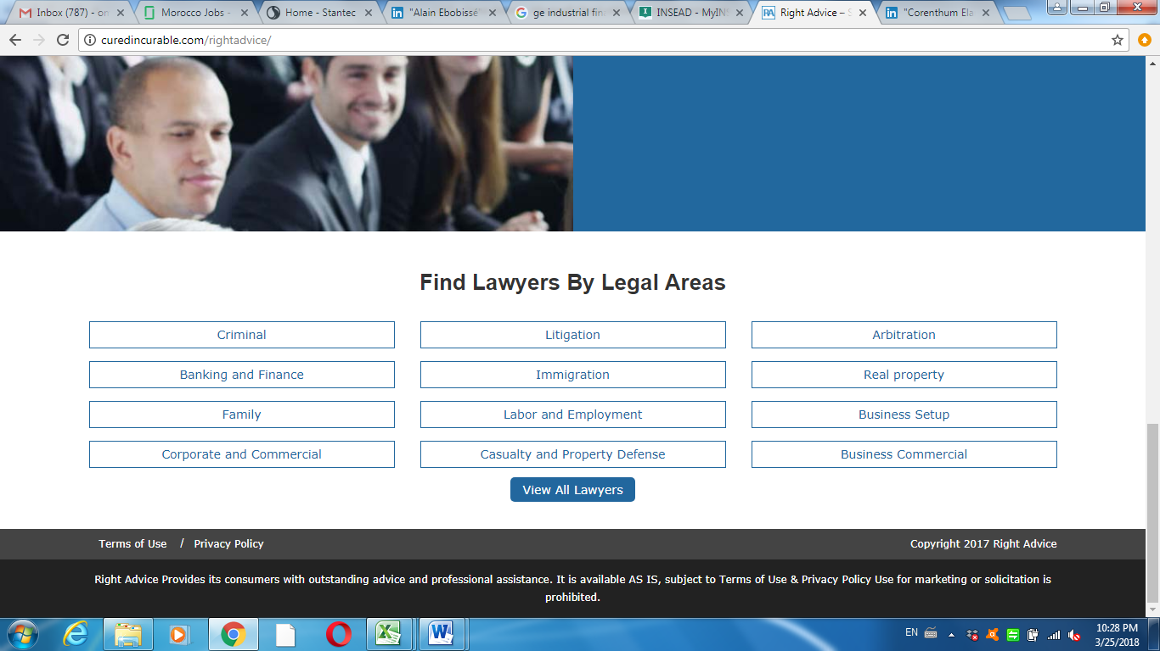

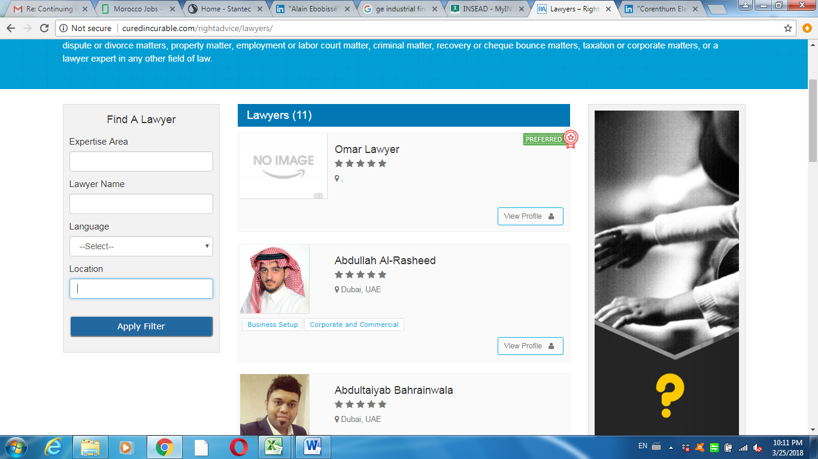

1. When navigating, the top part of the page should be frozen as you scroll down;

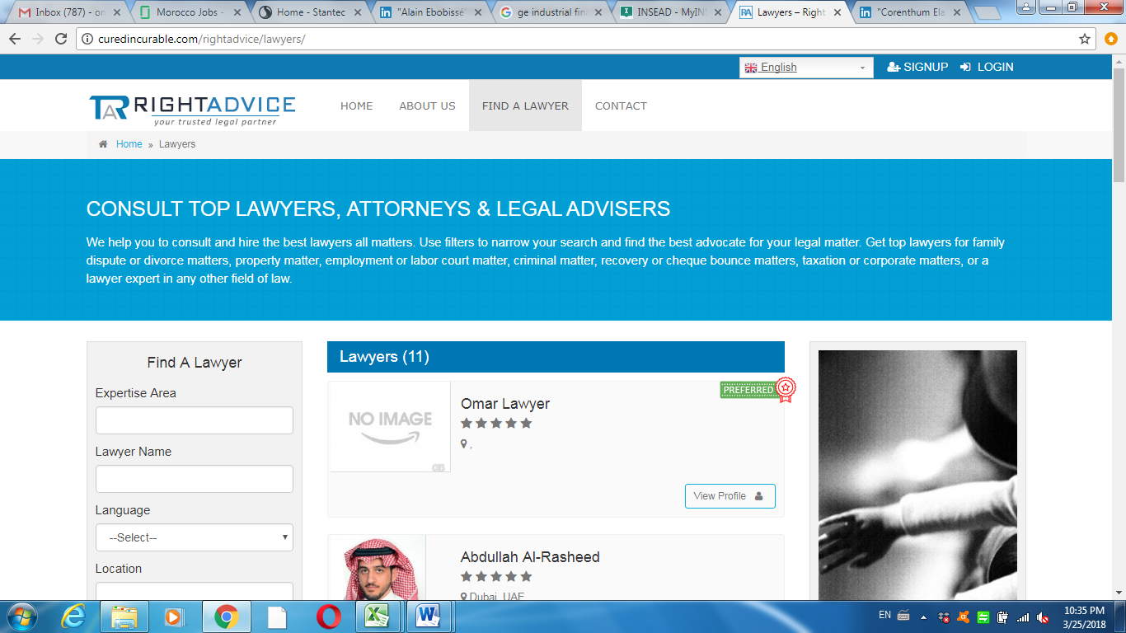

1. Both lawyer and client sign-up pages should have country then city drop down and not city then country. For instance, you select in country India, then only Indian cities appear in the city fields.

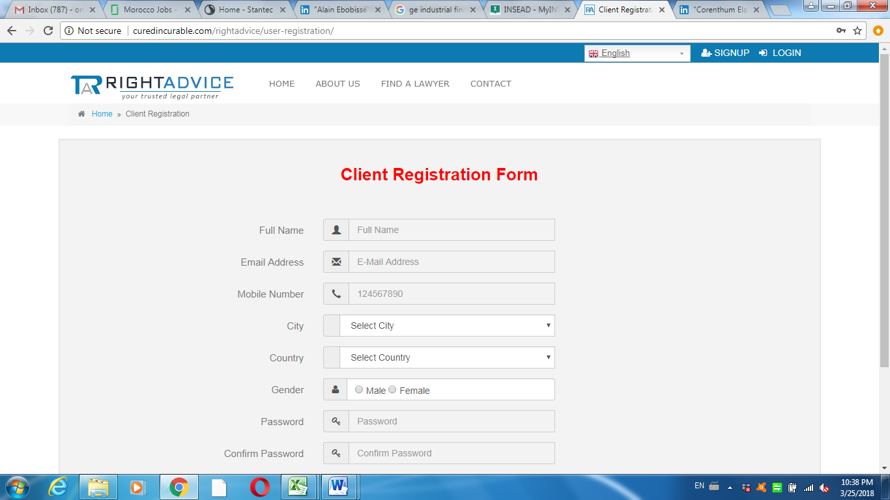

1. I have updated the address of a lawyer testcase “Omar Lawyer” with the following logins:

Email: [omerhom@gmail.com](mailto:omerhom@gmail.com) and pw: 21081980 then I saved the changes, however when I looked up the profile of the lawyer as a normal website visitor, the address remained unchanged and showed dubai instead of rabat

1. When loged in as a lawyer, I am still seeing links for “blog” and “news” which were removed from other parts of the site so kindly remove:

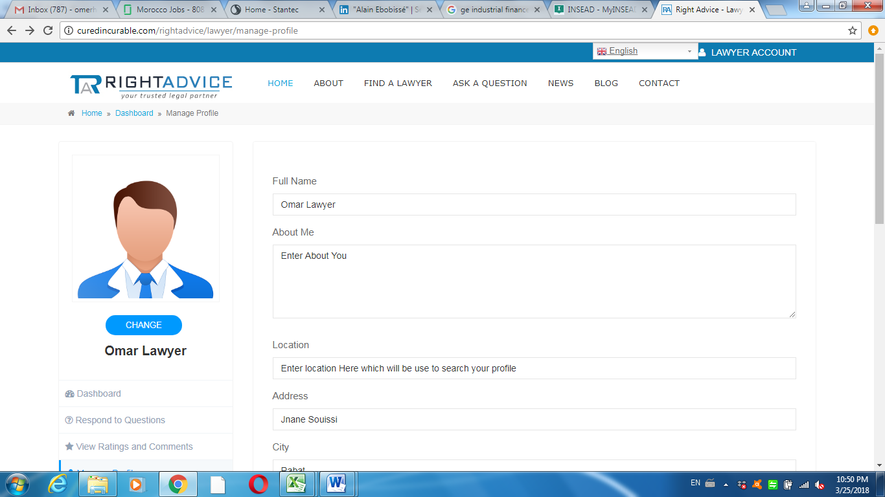

1. The text from contact us page needs to be updated to our text because right now it is just a place filler. Kindly replace to:

“Our team at RightAdvice is happy to hear from you. Kindly either fill the sections below or email us directly at [contact@rightadvice.ae](mailto:contact@rightadvice.ae)

Leave the questionnaire but remove the text on the right.

Kindly have the questionnaire pointing to: [contact@rightadvice.ae](mailto:contact@rightadvice.ae)